Ds Assignment 9
-By Gavisht Singh
#include <iostream>
#include <vector>
#include <queue>
using namespace std;

void BFS(int start, vector<vector<int>>& adj, int n) {
vector<bool> visited(n, false);
queue<int> q;

visited[start] = true;
q.push(start);

cout << "BFS starting from node " << start << ": ";

while (!q.empty()) {
int u = q.front();
q.pop();
cout << u << " ";

for (int v : adj[u]) {
if (!visited[v]) {
visited[v] = true;
q.push(v);
}
}
}
cout << endl;
}

int main() {
int n = 6;
vector<vector<int>> adj(n);

adj[0] = {1, 2};
adj[1] = {0, 3, 4};
adj[2] = {0, 4};
adj[3] = {1};
adj[4] = {1, 2, 5};
adj[5] = {4};

BFS(0, adj, n);
cout<<"\nGavisht Singh \t1024030358 \t2C24";

return 0;
}
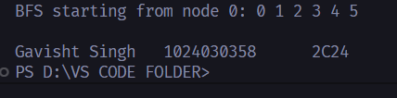
#include <iostream>
#include <vector>
using namespace std;

void DFSUtil(int u, vector<vector<int>>& adj, vector<bool>& visited) {
visited[u] = true;
cout << u << " ";

for (int v : adj[u]) {
if (!visited[v]) DFSUtil(v, adj, visited);
}
}

void DFS(int start, vector<vector<int>>& adj, int n) {
vector<bool> visited(n, false);
cout << "DFS starting from node " << start << ": ";
DFSUtil(start, adj, visited);
cout << endl;
}

int main() {
int n = 6;
vector<vector<int>> adj(n);

adj[0] = {1, 2};
adj[1] = {0, 3, 4};
adj[2] = {0, 4};
adj[3] = {1};
adj[4] = {1, 2, 5};
adj[5] = {4};

DFS(0, adj, n);
cout<<"\Gavisht Singh \t1024030358 \t2C24";
return 0;
}
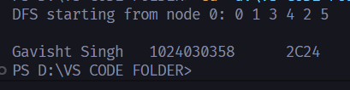

#include <iostream>
#include <vector>
#include <algorithm>
using namespace std;

struct Edge {
int u, v, w;
};

struct DSU {
vector<int> parent, rank;
DSU(int n) : parent(n), rank(n, 0) {
for (int i = 0; i < n; i++) parent[i] = i;
}
int find(int x) {
if (parent[x] != x) parent[x] = find(parent[x]);
return parent[x];
}
void unite(int x, int y) {
x = find(x); y = find(y);
if (x != y) {
if (rank[x] < rank[y]) swap(x, y);
parent[y] = x;
if (rank[x] == rank[y]) rank[x]++;
}
}
};

int main() {
int n = 5;
vector<Edge> edges = {
{0, 1, 10}, {0, 2, 6}, {0, 3, 5},
{1, 3, 15}, {2, 3, 4}
};

sort(edges.begin(), edges.end(), [](Edge a, Edge b) {
return a.w < b.w;
});

DSU dsu(n);

cout << "Kruskal MST:\n";
int mst_weight = 0;

for (auto& e : edges) {
if (dsu.find(e.u) != dsu.find(e.v)) {
dsu.unite(e.u, e.v);
cout << e.u << " - " << e.v << " : " << e.w << endl;
mst_weight += e.w;
}
}

cout << "Total Weight = " << mst_weight << endl;
cout<<"\nGavisht Singh \t1024030358 \t2C24";
return 0;
}
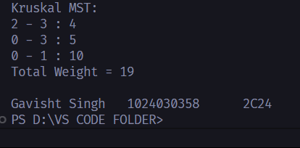
#include <iostream>
#include <vector>
#include <queue>
using namespace std;

typedef pair<int,int> pii; // {weight, node}

int main() {
int n = 5;
vector<vector<pii>> adj(n);

auto add = [&](int u, int v, int w) {
adj[u].push_back({v, w});
adj[v].push_back({u, w});
};

add(0, 1, 2);
add(0, 3, 6);
add(1, 2, 3);
add(1, 3, 8);
add(1, 4, 5);
add(2, 4, 7);

priority_queue<pii, vector<pii>, greater<pii>> pq;
vector<bool> inMST(n, false);

pq.push({0, 0});
int mst_weight = 0;

cout << "Prim's MST:\n";

while (!pq.empty()) {
auto [w, u] = pq.top();
pq.pop();

if (inMST[u]) continue;
inMST[u] = true;

cout << "Take node " << u << " with weight " << w << endl;
mst_weight += w;

for (auto &edge : adj[u]) {
int v = edge.first;
int weight = edge.second;
if (!inMST[v]) pq.push({weight, v});
}
}

cout << "Total Weight = " << mst_weight << endl;
cout<<"\nGavisht Singh \t1024030358 \t2C24";
return 0;
}
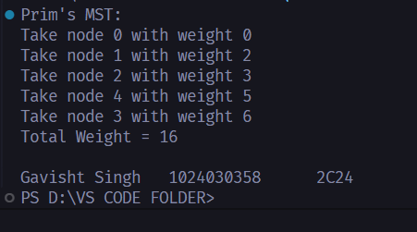
#include <iostream>
#include <vector>
#include <queue>
using namespace std;

typedef pair<int,int> pii; // {distance, node}

void dijkstra(int src, vector<vector<pii>>& adj, int n) {
vector<int> dist(n, 1e9);
priority_queue<pii, vector<pii>, greater<pii>> pq;

dist[src] = 0;
pq.push({0, src});

while (!pq.empty()) {
auto [d, u] = pq.top();
pq.pop();

if (d > dist[u]) continue;

for (auto &edge : adj[u]) {
int v = edge.first;
int w = edge.second;

if (dist[u] + w < dist[v]) {
dist[v] = dist[u] + w;
pq.push({dist[v], v});
}
}
}

cout << "Shortest distances from node " << src << ":\n";
for (int i = 0; i < n; i++)
cout << "Node " << i << " : " << dist[i] << endl;
}

int main() {
int n = 5;
vector<vector<pii>> adj(n);

auto add = [&](int u, int v, int w) {
adj[u].push_back({v, w});
adj[v].push_back({u, w});
};

add(0, 1, 4);
add(0, 2, 1);
add(2, 1, 2);
add(1, 3, 1);
add(2, 3, 5);
add(3, 4, 3);

dijkstra(0, adj, n);
cout<<"\nGavisht Singh \t1024030358 \t2C24";
return 0;
}
